**Q1**. Binary search tree is a tree data structure where the left subtree of data structure contains value of node less than node and right subtree contains values of node greater than node itself.

Here the node can have minimum 0 and maximum 2 children.

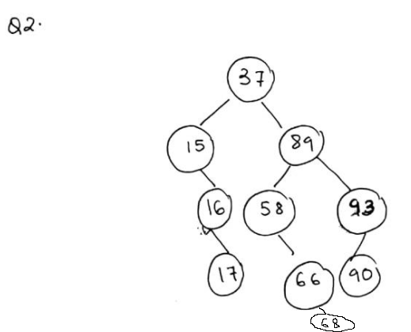

**Q3**

In order traversal: Left -> Root -> Right

15 16 17 37 58 66 89 90 93

Preorder Traversal: Root -> Left -> Right

37 15 16 17 89 58 66 93 90

Post order traversal: Left -> Right -> Root

17 16 15 66 58 90 93 89 37

**Q4**. If a set of elements is inserted into a BST in two

different orders, will the two corresponding BSTs look

the same?

Answer: No

Will the inorder traversal be the same?

Answer: Yes

Will the postorder traversal be the same?

Answer: No

Will the preorder traversal be the same?

Answer: No

Q5/6/7

Show the result of deleting 66 from the BST

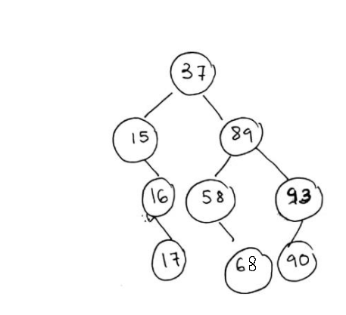

Show the result of deleting 89 from the BST

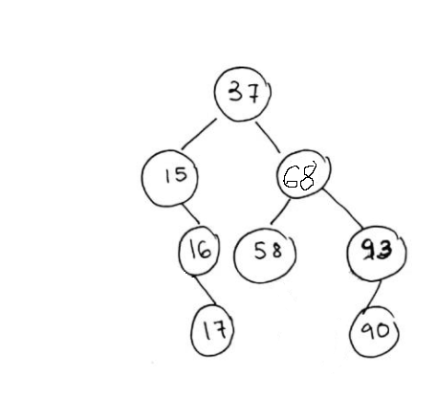

Show the result of deleting 37 from the BST

